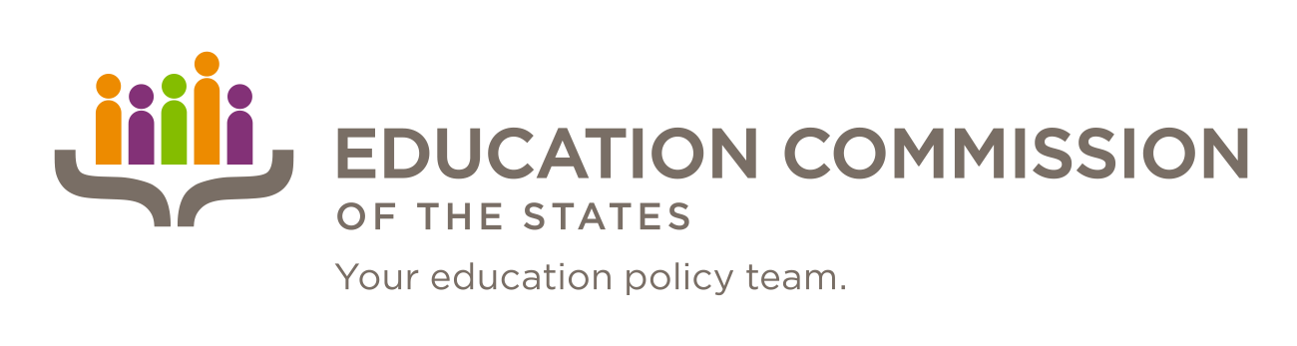

CALL FOR ENTRY

Submissions Due: February 1, 2016

Education Commission of the States
700 Broadway, Suite 810
Denver, Colorado 80203

Accepting Submissions for Commissioned Murals; Theme:
“Serving the people behind the policy.”

Please submit mural design sketch and application to:
Amy Skinner, Director of Communications at ECS (askinner@ecs.org or 303-299-3609)

Education Commission of the States
Requesting submissions for commissioned murals:
“Serving the people behind the policy.”
Submissions due: February 1, 2016
Purpose
Education Commission of the States covers the full spectrum of education policy and dives deeply into certain key issues impacting all states such as college readiness, state financial aid, civic learning and engagement, and arts education. Additionally, the internal structure of Education Commission of the States has staff specializing in several specific areas: early learning, K-12, high school and STEM, and postsecondary and workforce. Our policy experts respond to state research requests on the full spectrum of education policy issues.

We have recently moved to a new space in Denver and are looking for an enthusiastic and motivated Colorado high school artist who could design and paint two murals in our office.
- One mural will be of our logo and tagline on the front wall of our office. The wall is made of drywall, painted white and the space for the painted logo is five feet wide by four feet high (5’x4’).
- The other mural will be the chosen artist’s representation of our work and internal motto “Serving the people behind the policy.” This mural will be in our employee break room on a large wall, again drywall, with a space of eight feet wide by five feet high (8’x5’).

Along with paying a small commission (or contribution to a college fund) of $500.00 plus paying for supplies up to $300.00, we will recognize the artist in our office with a plaque and photo for future Education Commission of the States Commissioners (Governors, Legislators, Education Commissioners, University Presidents, etc.) to view.

Qualifications for Entry:
- Student must be a Colorado high school student
- Student must have teacher and parent support as evidenced on entry form
- Student design sketch expressing the student’s views around the theme of “Serving the people behind the policy.”
- Entries must :
  - Design sketch must be entered as a PDF file
  - Include a typed artist statement
  - Include a completed entry form
- All three portions of the entry must be submitted together.

Artist Statement Guidance:
The purpose of the artist statement is to promote reflective and critical thinking regarding visual art and to enhance visual awareness skills and processes. When sharing your insights with an audience, it is important to formally articulate your insights about your piece, the process you used and any other details that inform the viewer. You are the best teacher about your work! Below are some guiding questions to help you prepare. There is also a sample artist statement provided for your reference.
Guiding questions for your statement:
(Choose any/all that you are excited to address and feel free to add any other information you think is important):
- Does your design have a title? Why did you choose that title?
- How does your design represent the theme “Serving the people behind the policy?”
- What is the most important thing you learned in designing this artwork?
- What do you hope your viewers will take away from this piece?
- What challenges might you encounter in creating this piece? How might you overcome the challenge?
- Why is art important? Has art made a difference for you in your life? Why/How?
- Why is education important?
- What influences your artwork?
- What do you like best about being an artist?
- Why do you make art?

Read More About It!
If you are interested in more detail about preparing an artist statement, the links below give some great advice!
http://www.mollygordon.com/resources/marketingresources/artstatemt/
http://artiststatement.com/

Submission Process and Deadline

- An electronic copy of the entry form, artist statement, and PDF file of the design sketch should be submitted in a PDF format in one document and must be submitted to: askinner@ecs.org by 5:00 p.m. MST February 1, 2016. The winner will be notified by February 15, 2016. Faxes will not be accepted. Incomplete or late proposals will not be considered.

Submit applications by 5:00 p.m. MST on February 1, 2016 to:

Amy Skinner
Director of Communications at Education Commission of the States
askinner@ecs.org

“I AM A STUDENT OF CULTURE”

Education Commission of the States
Commissioned Mural Entry Form
“Serving the people behind the policy”
Submissions due: February 1, 2016

NAME OF ARTWORK: ______________________________________________________________________________

STUDENT NAME: _________________________________________________________________________________

AGE:_______________________________________ GRADE: ______________________________________________

SCHOOL:____________________________________ DISTRICT: ____________________________________________

STREET:______________________________ CITY: __________________________ ZIP CODE: ____________________

TEACHER’S NAME: _________________________________________________________________________________

TEACHER’S POSITION: ______________________________________________________________________________

TEACHER’S WORK PHONE: __________________________________________________________________________

TEACHER’S E-MAIL: ________________________________________________________________________________

TEACHER’S SIGNATURE: ____________________________________________________________________________
My signature verifies that I have read the contest requirements and approve my student’s entry of his or her original mural design. I assure that this is my student’s original artwork.

STUDENT SIGNATURE: _____________________________________________________________________________
My signature verifies that I have read the contest requirements to enter my artwork into the Education Commission of the States call for entry of a commissioned mural. I understand that by submitting my entry to this contest, my artwork becomes the sole property of the Education Commission of the States. I assure that this is my original work.

If a student is under 18, his or her parent or guardian must also sign the submission form.

PARENT’S/GUARDIAN’S SIGNATURE: _________________________________________________________________
My signature verifies that I have read the contest requirements and approve my child’s entry of his or her original artwork into the Education Commission of the States call for entry of a commissioned mural. I understand that by submitting my child’s entry to this contest, his/her artwork becomes the sole property of the Education Commission of the States.
PERMISSION TO DISPLAY ON WEB SITE/ IN PUBLICATIONS
The Education Commission of the States may choose to showcase the mural in an online gallery and could choose to include select images in other multimedia formats including, but not limited to, ECS’s web site, social media and publications. In doing so, images will be open for public view.
RELEASE AND UNDERSTANDING
We, the undersigned, grant our consent for public display of this student’s artwork by the Education Commission of the States.
_________________________________ _____________________________ __________________
Student Parent/Guardian Date

Education Commission of the States
Rubric used in the selection process:
“Serving the People Behind the Policy.”
Submissions due: February 1, 2016

Criteria for Entry:

Categories | Developing | Basic | Meets Expectations | Advanced
Relevance to the Theme “Serving the People Behind the Policy.”  Development of theme through creativity | - Clear connection to the theme | - Theme is prominent and clear to the viewer | - Theme is presented in a convincing or imaginative way | - Theme is prominent and clear to the viewer  - Addresses complex visual or conceptual ideas
Visual Effectiveness/Overall Appearance of Design  Evidence of thorough planning and preparation | - Shows consideration towards meaning and purposeful composition  - Provides details in objects | - Shows evidence of thought in placing objects in environment  - Indicates relationships between objects | - Shows effective evidence of thinking and decision making  - Shows effective understanding and use of expressive features and characteristics of art and design.  - Shows effective control of media  - Shows effective control of compositional format | - Shows excellent evidence of thinking, decision making or imagination  - Shows excellent use of technical skills and media  - Shows excellent compositional skills
Originality of Design  Uniqueness of expression of the idea | - Imaginative depiction of theme | - Uses media in a convincing or imaginative manner | - Shows self-direction and inspiration | - Shows inventiveness or experimentation  - Reflects sensitivity and/or subtlety  - Shows excellent evidence of personal style
Student clearly describes the artist’s intent for the artwork | - Demonstrates a meaningful personal response | - Ideas and connections are clear  - Demonstrates a meaningful personal response | - Ideas and connections are clear  - Demonstrates a meaningful personal response  - Details of creative process show artistic insight | - Ideas and connections are clear  - Demonstrates a meaningful personal response  - Details of creative process show artistic insight

Please submit: Student mural design sketch in a PDF file, typed artist statement, and completed entry form.

